**Annual Overview and Summary for Academy Programs 2019**

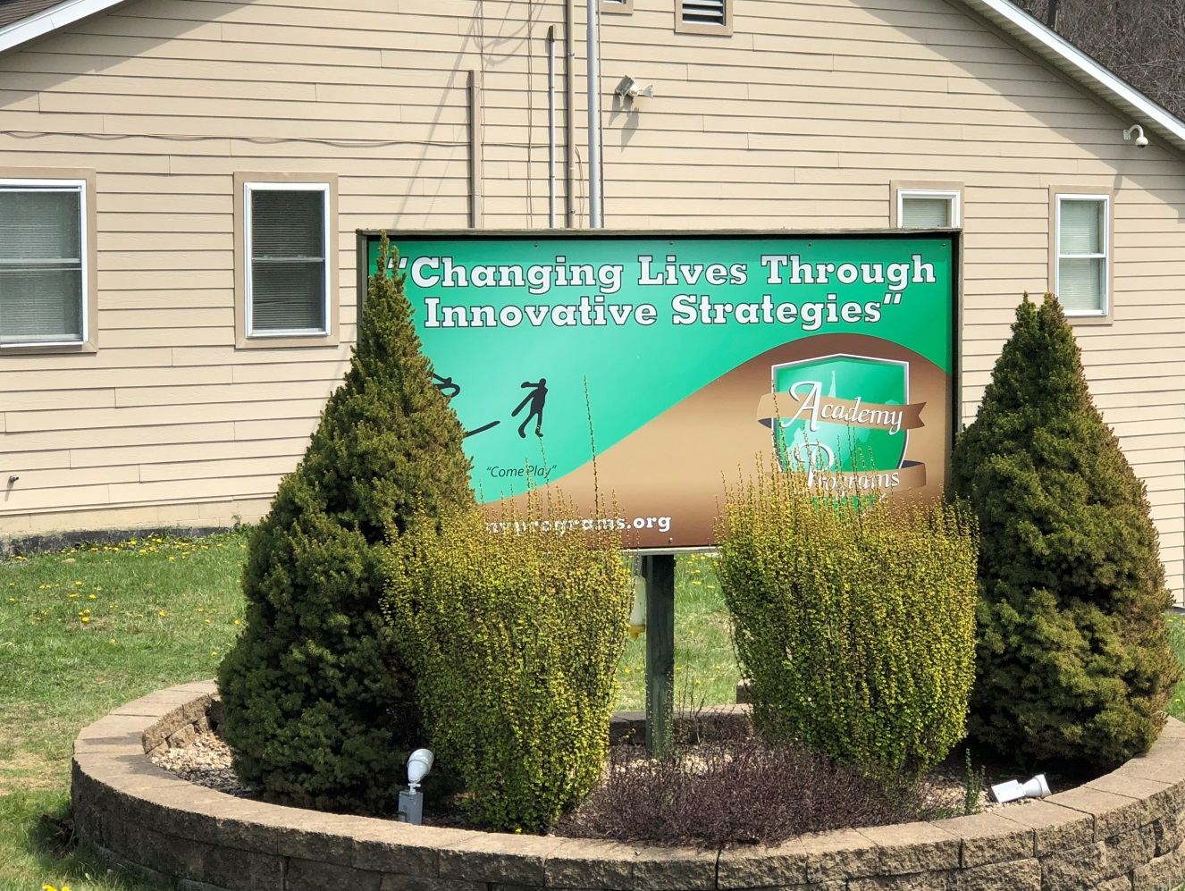

“Changing Lives Through Innovative Strategies” is more than just a catchy motto that adorns the sign at the entry to our campus; it has become integrated into our practice, the beacon for approaching our work with kids, a part of who we are as a company. Through our commitment to innovation in practice, Academy Programs has succeeded in setting the standard for children’s services in behavior modification, education, and recovery.

The Academy continues to maintain its commitment to Re-ED Philosophy as our guide for reaching children with emotional and behavioral disturbance. Created in the 1960’s, Re-ED is an intervention that provides an alternative to emphasis on psycho-dynamics in treatment and replaces it with an emphasis on education. Re-ED practice in informed by two basic assumptions. First, emotional disturbance is not something that a child or adolescent “has”, or not something in the person. It is not an illness, a disease, a disorder, or the by-product of pathology. We approach our work with kids believing that they are a product of their environment; an environment where bad habits have been learned as a means of adapting to, and overcoming the challenges present in their environment. As such, we attempt to replace those habits with positive and productive habits that will enable the child to live more successfully once returned to their natural environments.

Second, we believe that children derive greater benefit from life as it is lived, as opposed to life as it is talked about during therapy. Insight into the causal relationship of behavior and experiences is regarded as less important in generating behavior change as is actually experiencing the benefits of that change through successful and effective daily living. Success generates success and children who experience the benefits of living successfully on a daily basis gain the competence and confidence necessary to generate the desired behavior modification.

Given our commitment to the practice of Re-ED philosophy, success in education and improvement of academic competence continues to drive our approach to our work with students. Research and experience demonstrates the crucial importance of academic competence in improving the adjustment of children. As such, our treatment programming at Academy Programs begins with an attempt to repair academic deficits as a means of creating a gateway to address and improve behavior, performance, and adjustment deficits. Children who perform with competence and confidence in the classroom setting are more apt to perform likewise outside of the classroom.

Dr. Nicholas Hobbs, the founder of Project Re-ED, challenged future practitioners of his philosophy to maintain innovation in our work by recreating what Re-ED should become every day. He believed that in so doing, Re-ED would maintain its vitality and application to our work with children for generations to come. In good keeping with this challenge, Academy Programs continued its tradition of creating innovative programming activities and incorporating them into our treatment milieu.

In early 2019, winter storms gave us the opportunity to host a snowman building contest and a castle building competition, with hot chocolate being a well sought award. During the Spring, we focused on involving the students in developing new activities that emphasize team work, communication, decision making, community service and team building. As a result of their hard work, many of these new activities became a long-standing part of our programming and continue to use these activities in our work today. During Spring Break, we hosted a campus-wide cornhole tournament. Each group was able to design and construct their own game boards incorporating their group logos. The week also included daily learning and experiential activities where each day focused on the themes of different decades from the 1920’s into the future. We constructed two separate Escape Room challenges where groups used their problem-solving and group work skills to overcome the challenges. Our annual Battle of the Buildings competition continues to be an anticipated and enthusiasm-driven highlight of the year. YALE Academy emerged as the victor once again scoring landmark wins in academics and enthusiasm.

The Academy continued to integrate athletic programming into our treatment milieu as a means of challenging the physical capabilities of our students. Re-Ed philosophy states that physical fitness and psychological fitness are both constructed within the same person. As such, improving psychological fitness, as well as physical fitness, results in enhanced effective functioning. We believe that our athletic programming aides us in meeting this need for our student body. The Cherokee group from Youth Academy demonstrated dominance by claiming victory in all three sporting events for the year among the girls’ groups. Among the boys’ group, the Sioux group of Yore Academy was the champions of the basketball season. The Titans group of YALE Academy claimed victory in both volleyball and football for the year.

Re-ED emphasizes the importance of community and experiencing the benefits and responsibilities of being responsible stewards of our community. As such, our commitment to community service projects continued throughout the year as well. In 2019, groups from the Academy would volunteer support for a wide range of community projects including the Governor’s Adopt-A-Highway program, the Veterans Administration Nursing Home, Marion County Humane Society, Madison Center, Arbors Nursing Home, Ronald McDonald House, Helping The Homeless of Harrison County, Christian Help, and Fairmont Regional Medical Center.

In our efforts to be leaders in our industry and to set the standard for other child welfare providers to achieve, the Academy underwent multiple external reviews by the state licensing body, the Council on Accreditation, and our managed care organization. All three programs (Youth Academy, Yore Academy and YALE Academy) achieved exceptional ratings across the board from our licensing specialist. Youth, Yore and YALE Academy each received an expedited approval for continued accreditation with no need for remediation in our practice. At the conclusion of an intensive audit by our managed care organization, they confirmed that the Academy’s performance indicators for all three programs were among the highest in West Virginia. In June, staff at the Academy submitted one of our exclusive practice initiatives to the Council on Accreditation for consideration in their Innovative Practices Award. Though we were not selected to achieve the award, our work remained under consideration until the final round of selections.

Nicholas Hobbs challenged future Re-ED programs to create an environment “attuned to the needs of children for affection, play, adventure, learning, and a sense for the future as possibility”. Through our continued efforts to remain on the cutting edge of providing responsible, results-oriented services to our students, Academy Programs continues its efforts to “Changing Lives Through Innovative Strategies”!

The 2019 Academy Programs Annual Report will go into greater detail by addressing information in the following areas:

* Academics
* Average Daily Census
* Occupancy Rate
* Average Length of Stay
* Total Number of Residents Served
* Permanency of Life Situation
* Presenting Diagnosis and Success Rate
* Graduating Academy Programs
* Child and Adolescent Functional Assessment Scale
* Smart Recovery
* Referrals
* Reportable Incidents/Safety Report-CIRT Review
* Community Family Intensive Treatment (CFIT)
* General Staffing Patterns
* Staff Retention and Turnover
* Satisfaction Surveys
* Expenditures & Revenue

# Academics

Our school continues to be the highest academic performing school among all WVDE residential on-grounds schools since we completed our first year in 2008-2009.

While at Academy Programs, 64% of all students increased their Reading scores a minimum of one grade level or more and 66% of all students increased their Math scores a minimum of one grade level or more.

26% of our enrollment earned the semester Superior Honor Roll, with 4 of those having a perfect 4.0 GPA (Superior Honor Roll is 3.5-4.0 with no grades of a “C”.) The semester honor roll is harder to achieve because it includes two different grading quarters and semester exams all averaged together. 36% of our enrollment earned Distinguished Honor Roll.  (Distinguished Honor Roll is 3.0-3.49 with no grades of a “D”.) A total of 62% of our enrollment earned the semester honor roll.

Eight credits are available to be earned during the traditional school year

* + Five core subjects of PE, Math, English, Science, and Social Studies
  + Special Education and Options Pathways
  + Electives include but are not limited to Automotive Technology (Students are able to earn a National certification as a student ASE Certified Mechanics), Facilities Maintenance, Career Integrated Experiential Learning, Communications, Geography, Piano, Art, Music Appreciation, Health, Fitness, Computer Applications, Psychology, Sociology, Medical Terminology, Parenting, Child Development, Criminal Justice, Test Strategies, Journalism, Virtual School programming

A full thematic based summer school is offered in which students can earn up to two credits toward high school graduation (the majority of public school systems do not offer a summer school.) Our summer curriculum is designed to be “hands on learning” with many off campus field trips that teach the students to compare and contrast “book learning” to the real world. Examples of trips include but are not limited to; Seneca Caverns, Pittsburgh Zoo, Carnegie Science Center, NASA Challenger Learning Center.

In addition, all of our teachers are “Highly Qualified” under Federal guidelines. We have 1:1 student to computer ratio. All student grades, transcripts, etc. are kept on the statewide public school computer system “WVEIS” (West Virginia Education Information System) which makes the transfer of student data for transition back to public schools immediate and seamless.

We are a Federal “Title I” school which enables us to receive federal funding to run academic programs for at risk children. This includes:

* + Tutoring
    - 3 tutors, each working 3 days per week
    - Teachers hired to work on Saturdays for tutoring and Academic Remediation, Enrichment, and Acceleration (AREA)]
  + Full time Reading Intervention Specialist
  + Full time Math Intervention Specialist
  + Full time Transition Specialist providing discharge transition services for up to 12 months

Our Automotive Technology CTE program and our Facilities Maintenance CTE program enable our school to do the “Option Pathways,” which increases opportunities to earn a high school diploma through alternative methods. Our Automotive Technology program has received commendations for the effective implementation of Simulated Workplace initiatives

Auto Tech students earn national ASE Student Certification in multiple areas of auto technology. This certification is recognized as the industry standard for mechanic competency in the automotive repair industry.

Career Integrated Experiential Learning (CTE course) students earned approximately:

* + 20 OHSA 10 certifications
  + 50 CPR certifications
  + 40 Serve Safe certifications
  + 600 Tooling U certifications

Students may be enrolled in distance learning classes to supplement our direct delivery:

* + “Credit Recovery” classes for students that have previously failed a class and need to retake that class for a credit
  + “Virtual School” for students that need a particular class that our school either can’t offer or that class won’t fit in our course offering schedule
  + College classes
  + Career Technical Education coursework

Numerous other ODTP schools have toured our school due to directives from the superintendent as we are considered “the model school” for ODTP. Our school was featured in a national article written on behalf of World Vision. The article wanted to focus on how our school is positively changing lives of some of the toughest kids.

Our school implements a “Positive Behavior Support Program” called Reaching for the Stars, which recognize academic excellence (3.4 in all eight classes for the week), appropriate behaviors, and perfect attendance.  Individualized instructional plans are developed for each student, regardless of whether they are special education or not.  Our instructional strategies have been commended by the WV Board of Education’s auditing agency, Office of Education Performance Audits.

Three WVDE Office of Diversion and Transition Programs’ Teacher of the Year award winners on staff at Academy Programs.

* + Chris Kelley, Math
  + Hannah Long, English
  + Barbie Clutter, Social Studies

Two measures of academic success, credits earned and GPA, are illustrated below:

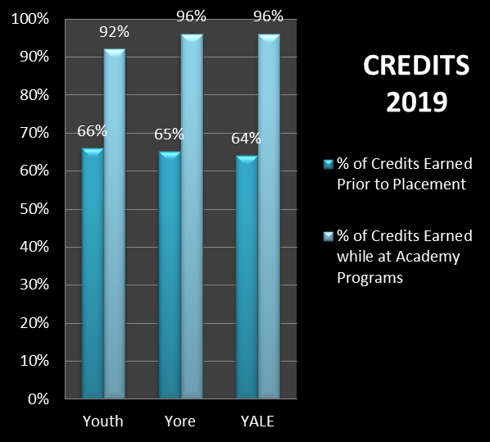 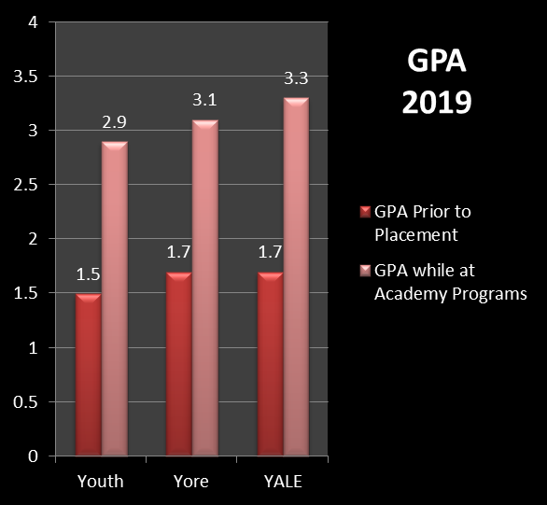

# Average Daily Census and Occupancy Rate

Academy Programs served 164 at-risk children in 2019. The normal attendance for Youth Academy is 22 residents and 24 residents each for Yore and YALE Academy. In times of need, the judicial system will request that additional children be placed in order to meet their immediate treatment needs. With one exception, Academy Programs met or exceeded capacity consistently throughout each month. The chart below represents the average daily census per month in 2019.

With the increased census, occupancy for the year exceeded the normal expectation for days in care for each program. In total, Academy Programs provided an additional 587 days of treatment to children in need.

# Average Length of Stay

The majority of children complete the program in seven to nine months. In 2019, males had a shorter length of stay overall.

# Total Number of Residents Served

Academy Programs serves children from all across West Virginia. The county with the highest number of kids in our care was Kanawha County (56), followed by Harrison (19), Cabell (13) and Randolph (13). In the map below, the counties shaded yellow show where our children call home:

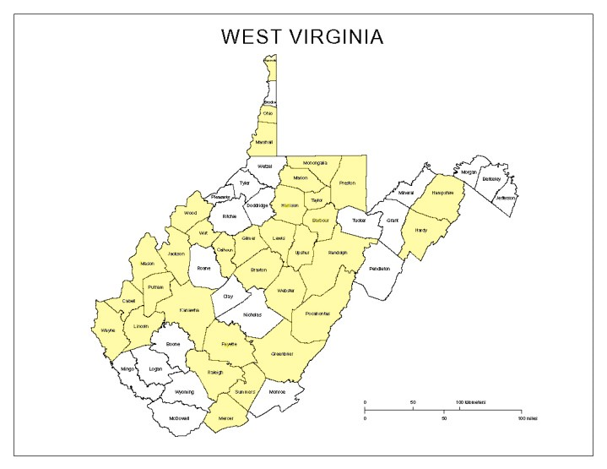

Boys outnumbered girls in 2019. Overall, 66% of residents were males, 34% were females. Females were slightly older than males.

# Permanency of Life

Positive outcome measures stipulate that 70% of all kids receiving services for 90 days or longer will be discharged to a home setting (foster home, birth family, adoptive, kinship care, lesser restrictive, or independence). Simply stated, permanency means family. It means having positive, healthy, nurturing relationships with adults who provide emotional, financial, moral, educational, and other kinds of support as youth mature into adults. Ideally, permanency takes the form of a relationship that has a legal component that provides a parent-child relationship. Older youth, regardless of age, need and deserve to be connected to a permanent family and support system that both lifts them up and cushions them if they fall. In 2019, Academy Programs achieved 92% success rate in achieving a positive permanency of life for the children discharging from care.

# Presenting Diagnosis and Success Rate

As in years past, the most prevalent diagnoses continue to be in the Disruptive Behavior Disorder category as well as the Cannabis Abuse Disorder class.

Successful discharges are achieved through planning. Whenever possible, Academy Programs coordinates discharge planning with all of the members of the Multidisciplinary Treatment Team. Recommendations for further treatment services, school placement, and other supports necessary to help the student maintain the gains they achieved while with us are provided to the team. At times, students are released at court prior to completion of the program and without benefit of the planning process. Although sometimes they are being released back into their parents’ care, it is without benefit of planned community services. At other times, children elope and remain at large, causing them to be released from the program. Thirdly, they may be in need of a different type of service or possibly detention in order to be maintained safely. Academy Programs completed 87% planned discharges in 2019.

# Graduating Academy Programs

There are many standard assessments that, in one way or another, claim to track and monitor a child’s progress through a treatment program. However, they are generally defined by data, charts, and numbers as opposed to a real time, tangible tool for making the child aware of how they have progressed and/or be able to identify what steps they need to take to become completely successful. Assessments are designed to measure ecology, behavior, functioning, and academic performance, but few are available to actually demonstrate success in completing a particular treatment program. For this reason, Academy Programs has developed and employs a six phase program known as Graduating Academy Programs, or GAP, delineating the steps a child must take in order to fully and successfully complete the program and utilize the strategies of this program as an integral part of the treatment planning process.

This program was developed by combining the stages of development that a child goes through in an out-of-home placement with the Stages of Change model in the therapeutic process to identify and target a list of treatment milestones a student must master in order to maximize their opportunities for successful living post completion of our program. The theory in effect here is that a student who is successfully able to overcome challenges to reach each milestone possesses the skills needed to return home and live in a manner more satisfying to themselves, and more satisfying to those around them.

In our efforts to generate outcomes that are evidence based in accordance with our company values, we have developed and implemented this program in the treatment milieu. This six phase program is designed to accurately and consistently identify the steps a child must take in order to complete the program and make the strategies of this program a consistent component of the treatment planning process. Through the application of this program, the Academy is able to offer a consistent product to our referral sources as well as an effective treatment intervention for our student population. We are able to benchmark a child’s progress through the program and identify areas that a child must address and master in order to complete the program. The focus of the GAP program is completion of treatment milestones within the milieu and is specific to each child’s individual treatment needs. It allows us to readily identify treatment objectives upon entry and provides each child a tangible list of objectives. The program allows children to gauge where they are in the treatment process and identify future challenges to complete the program. It also allows the parent(s), social worker, JPO, and judges to readily track a child’s progress through the program.

The Academy believes that a child who has successfully addressed the challenges at each bridge in the GAP Program has effectively overcome the deficits that prevented them from living successfully in their natural environment. Behavioral and substance abuse issues have been addressed through clinical intervention and successful daily living. Academic deficits have been repaired and the student has been in the care of our Transition Specialist who will follow the student back into their home school to ensure a successful transition.

Students who have graduated or have completed bridge 5 or above are considered an optimal discharge. Over 75% of those leaving Academy Programs are in this category.

# Child and Adolescent Functioning Scale (CAFAS)

The Child and Adolescent Functional Assessment Scale assesses the degree of impairment in youth with emotional, behavioral, psychiatric, or substance use problems. The CAFAS provides an objective, comprehensive assessment of a youth’s needs that is sensitive to change to over time, making it the most widely used outcome measure available. Using information collected during a routine clinical interview, the practitioner selects items that describe the youth’s problematic behaviors, as well as strengths and goals. This is done for eight life domains: At School, At Home, in the Community (delinquency), Behavior Toward Others, Moods/emotions, Self Harm, Substance Use, and Thinking (assessing irrationality). A Total Score and subscale scores are generated, with higher scores indicating greater impairment in day-to-day functioning. Therefore, as treatment progresses, lower CAFAS total and subscale scores indicate improvement.

# Self-Management and Recovery Training (SMART)

SMART Recovery is an abstinence-oriented method for individuals with addictive problems. The self-empowering, mutual support meetings focus on ideas and techniques to help change your life from one that is self-destructive and unhappy to one that is constructive and satisfying. SMART Recovery does not use labels like “addict” or “alcoholic.” Scientifically validated methods designed to empower you to change and to develop a more positive lifestyle are taught to each individual. In SMART we focus on teaching coping skills that work well short- and long-term. Ideas are based on what addiction science has shown to be effective. We are not much concerned with the past, except to learn from it. We focus on present-day events and the causes of self-destructive behaviors. We concentrate on what to do about them to achieve a positive lifestyle change, especially in the areas of our lives that are related to harmful addictive behavior.

SMART Recovery’s approach to behavioral change is built around a 4-Point Program®: (1) Building and maintaining the motivation to change. (2) Coping with urges to use. (3) Managing thoughts, feelings, and behaviors in an effective way without addictive behaviors. (4) Living a balanced, positive, and healthy life.

# Referrals

Referrals for children needing treatment services are made to Academy Programs on a daily basis. Unfortunately, we are not able to provide services to all of them. Some are not appropriate for our services, while others may need more immediate attention that can’t be provided at that time.

Referrals are received from all regions in West Virginia. The most referrals in 2019 were from Region II, shown below in blue on the map.

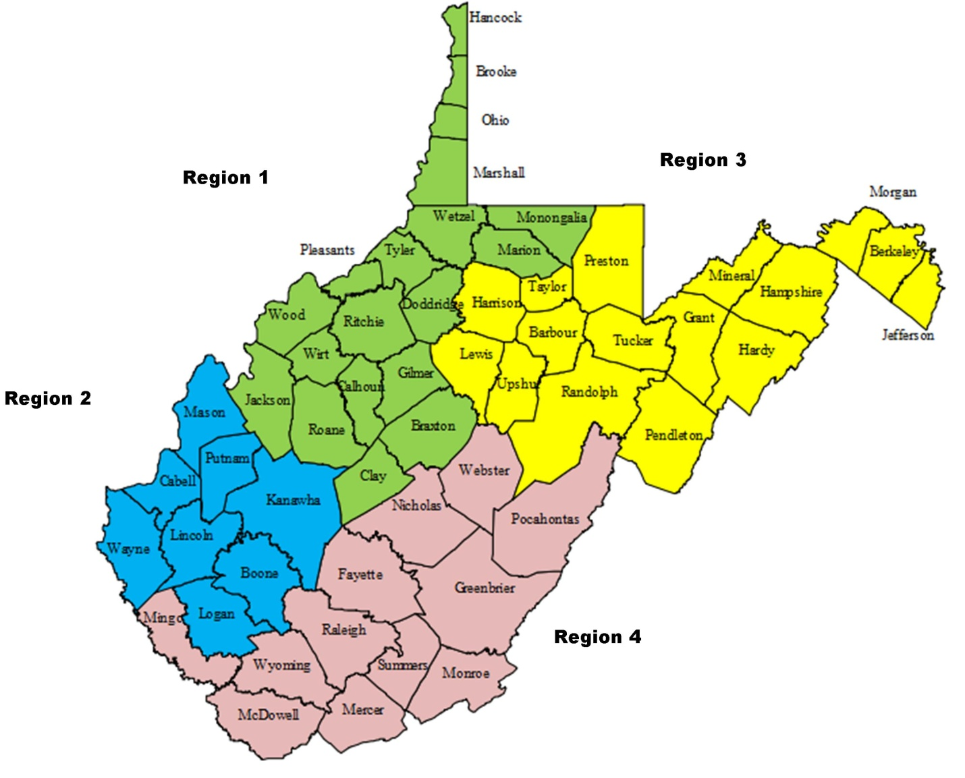 

# Critical Incident Review Team (CIRT)

The Critical Incident Review Team reviews all incidents and incident reports in order to investigate any incident which may have had the potential for harming a resident or residents emotionally or physically. Findings of the CIRT team are reported monthly to the Safety Committee. Any trends or patterns noted along with potential suggestions or corrective actions to be adopted are then presented to the senior Management Team for implementation. Overall incidents for both Yore Academy and YALE Academy show a decrease in 2019.



# Community Family Intensive Treatment (CFIT)

CFIT (Community Family Intensive Treatment) is designed to provide an array of services to assist at-risk families and children of all ages. The model is a combination of Social Necessity and Medical Necessity services. The combination of these services allows the child and/or family to receive specific attention to their needs. As in 2019, all referrals for services were made from Harrison County DHHR workers. The service requested was a Comprehensive Assessment Planning System or CAPS. It is an assessment of needs and strengths that cumulates in a plan of recommended services or actions.

# General Staff Patterns and Turnover

We are informed by our commitment to our philosophy that the most prominent difference in the Re-ED program and other mental health interventions is the fullness and purposefulness of each day in the life of a child. The one factor that will determine the success in creating such an environment is the caliber of staff present to make it possible. Our challenges over the past year have not been solely the training and retention of quality staff who work directly with children, but the absence of work force investment. In spite of marketing open positions throughout the year, the number of resumes, applications, and interest enquiries has waned considerably compared to previous years. To combat this trend, the Academy boosted our salaries and compensation packages resulting in becoming the highest paid entry-level human service position in West Virginia. While this improvement has aided in the retention of our existing valuable human resources, recruiting new staff to fill vacant positions remains challenging.

A total of 17 full-time, direct care staff left their positions at Academy Programs in 2019. Total length of service varied from three to 18 months. While the Academy experienced minimal turnover in Administrative and Adjunct staffing positions, the turnover in service positions was marginally higher. The majority of employees who separated employment were Teacher/Counselors. The total turnover rate for direct-care positions in 2019 was 31%. This number remains consistent with the three-year average turnover ranging from a low of 25% to a high of 34%.

Recommendations for improvement in improving retention in 2019 from staff are listed below:

• Compensation that is commensurate with education and experience

• Greater support and presence from immediate supervisor

• Increased training and development on specific areas of concern

• More flexibility in the work schedules

As a result of this feedback from our staff, 2020 Program Improvement goals have been developed to target the following specific following areas:

• Improvements in on-the-job training through adjustments in Staff Mentoring protocols

• Increased training for front-line supervisors in Staff Development and Benchmarking protocols

• Modification of Clinical Supervision protocols to allow for an increase in training for staff to bolster their ability to address targeted behaviors

• Modifying and refining protocols for the development of staff schedules

# Staff Satisfaction Surveys

Surveys were distributed to all staff in 2019 to gauge their satisfaction in seven key areas. Gap analysis shows the difference between how important attributes/services are to staff and how satisfied they are with those attributes/services. By comparing importance (blue) and satisfaction (red) scores in the chart below, we used gap analysis to identify priorities for improvement. Those areas are:

Compensation that is commensurate with education and experience; greater support and presence from immediate supervisor; increased training and development on specific areas of concern; and more flexibility in the work schedules.

# Expenditures and Revenue

Expenditures for 2019 are divided between Administrative and Management costs and Treatment and Program services. Revenue sources are WV DHHR, WV Medicaid and payment for CFIT services.

**YOUTH ACADEMY**

**________________Sources of Revenue_______________% of Revenue____Dollar Amount_**

**WVDHHR 69.6% $1,436,322.62**

**WV Medicaid 29.9% $615,984.84**

**CFIT 0.5% $ 10,396.32**

**Total: $2,062,703.78**

**YORE ACADEMY**

**________________Sources of Revenue_______________% of Revenue____Dollar Amount_**

**WVDHHR 74% $1,946,322.32**

**WV Medicaid 31% $671,624.47**

**Total: $2,617,946.79**

**YALE ACADEMY**

**________________Sources of Revenue_______________% of Revenue____Dollar Amount_**

**WVDHHR 74% $1,960,581.28**

**WV Medicaid 31% $672,213.84**

**Total: $2,632,795.12**