**Annual Overview and Summary for Academy Programs 2020**

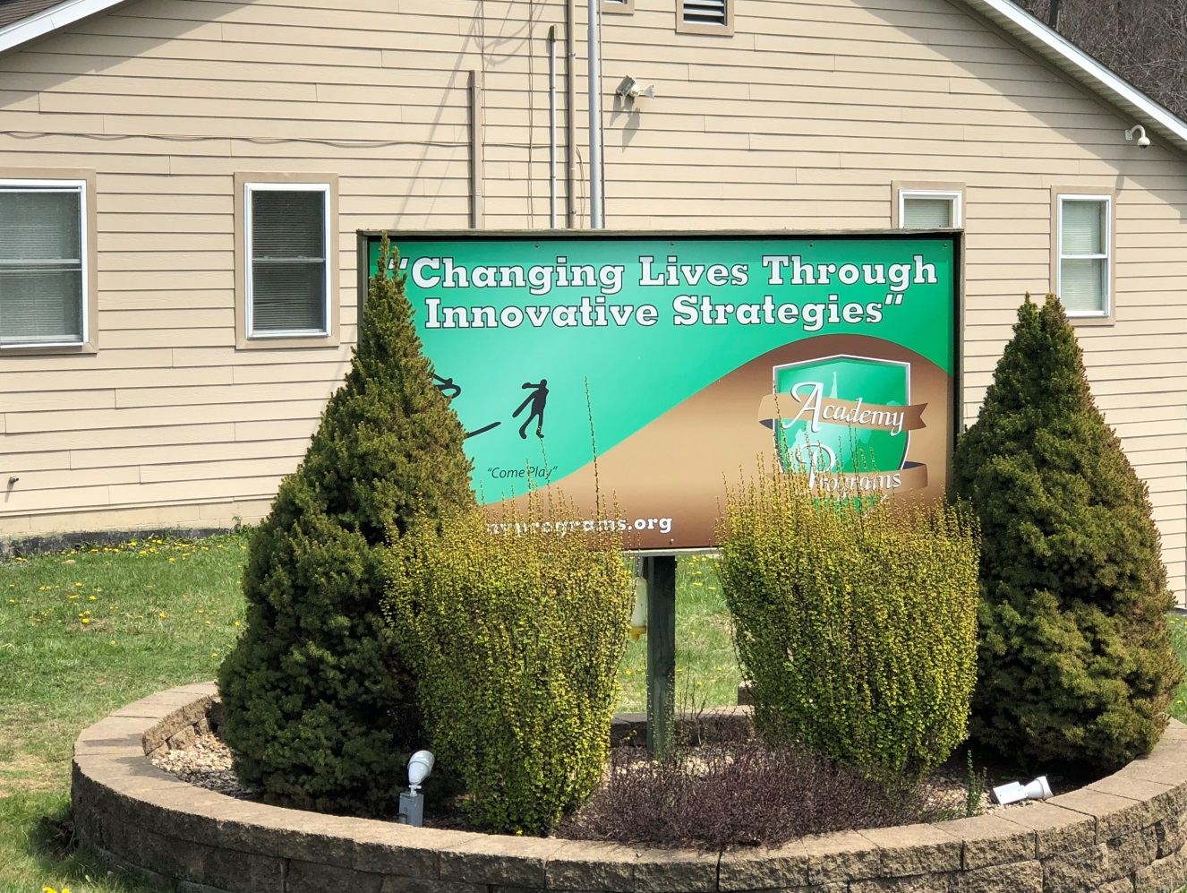

2020 has been a year that will be recorded as one of the most difficult and challenging years in human history. This year in our lives has been host to a world-wide pandemic with far reaching consequences on our lives and our work with kids. While Academy Programs was not able to enjoy being shielded from the fallout of the events and circumstances of this past year, we have enjoyed the opportunity to take on new challenges, to explore and implement new innovations in services and practices borne out of circumstance, and to continue our commitment to remaining on the cutting edge of children’s services without regard to the obstacles that were thrown our way. Throughout the course of 2020 we have realized that we must always remain ready to adapt to difficult situations, an intense frequency in change to policy, protocol, and practice, and explore new avenues of meeting the needs of the kids in our care even in the most impossible of circumstances.

The Academy’s continued commitment to Re-ED Philosophy has never been more critical than it has been in 2020. Over the years, Re-ED Philosophy has driven our efforts in education, positive community involvement, exploration of mind and body though our intramural sports program, and the enhancement of positive individual experiences through our campus-wide programming strategies. Each of these program caveats became difficult, if not impossible, due to the changes in protocols in response to COVID-19. While most would accept this as an unavoidable impact on their practice, the staff at Academy Programs embraced these challenges as an opportunity to create new programming strategies and new innovations in programming and remain committed to providing the highest possible standard of care for our students.

Education is a primary treatment concern in Re-ED Philosophy. Academic competence is of equal importance as involvement in traditional psychodynamic intervention. Nicholas Hobbs, the founder of Re-ED Philosophy, states “Although education has from the beginning been implicit, defining the fundamental character of the program, we now underscore education as a central strategy because research and experience have indicated the crucial importance of academic competence in the adjustment of children and youth”. As such, one of the primary goals in treatment is to repair academic deficits as a means of creating a gateway to address and improve behavior, performance, and adjustment.

Given the fallout from social distancing and increased precautions in response to COVID- 19, the traditional education programming at the Academy was disrupted for over six months. As a result, academic programming became woefully insufficient in addressing the needs of our service population. While accommodations were made for students to continue to complete assignments, engagement in a focused classroom were impossible due to increased universal precaution practices.

Active engagement in learning is a critical component to Re-ED programming. In fact, one of the factors that differentiate Re-ED schools from other academic institutions is the rich level of engagement and the promise each day brings for opportunities to explore, learn, and have adventure. In response to the need to return our student body to this level of engagement as a necessary in-road to treatment, it became necessary to develop our own educational programming to allow us to ensure these needs were being met in our treatment milieu.

In order to ensure the attainment of academic credit needed to repair deficits, we partnered with the Department of Education to provide a traditional classroom experience during a portion of our school day that was commensurate with the safety guidelines enacted by state officials. To provide a much-needed boost to the level of engagement, we combined specialized content provided in a traditional classroom setting with an outdoor, experiential learning curriculum component.

In addition to these modifications to our academic programming, we integrated treatment programming and traditional programming components into our day to achieve a greater sense of diversity in our activities and promote perpetual active engagement in learning, as well as treatment. These modifications to our traditional programming strategies allowed us to create days that were both educational, full of adventure, and packed with excitement. Such is the simplest nature of the Re-ED experience.

In order to ensure the accrual of academic credits, the first portion of the school day was conducted under the supervision of West Virginia Schools of Diversion and Transition staff. Each group was assigned one teacher from the WVSDT roster that provided instruction and guidance to Academy Teacher/Counselors in the completion of curricular assignments they provided. Unlike the traditional academic practice of each teacher providing a different assignment for students to complete, the Summer Session was thematic based and students worked on similar content across campus.

To allow students with special content/curricular needs to be adequately served, one class was directly facilitated by WVSDT staff. This class was referred to as the CTE class and occurred in the Auto Tech classroom. This course addressed the needs of those students requiring on-line instruction, CTE Credit, and preparation to take the TASC examination.

Re-ED writing informs us that “intelligence can be taught. The cognitive competence of children and adolescents can be considerably enhanced; they can be taught generic skills in the management of their lives as well as strategies for coping with the complex array of demands placed on them by family, school, community, and job.” In good keeping with that philosophy, Academy staff elected to revisit old-fashioned curriculum content and vocational skill in an effort to teach to basic intelligence by spending the second portion of the school day delivering specialized curriculum content that included:

* Employment Skills
  + Vocational Interest Inventory
  + Job search skills
  + Resume writing / application completion
  + Interviewing skills
  + Work ethic
* Mechanics 101
  + Checking tire air pressure
  + Changing a flat tire
  + Checking and monitoring fluid levels
  + Performing routine maintenance
  + Basic automotive components
  + Explaining a problem effectively to a technician
* Home Economics
  + Smart money management skills
  + Developing a budget and managing a checking account
  + Sewing, Ironing, and laundry
  + Writing a letter and addressing an envelope
  + Measurements and how to read a recipe
* Basic Household Maintenance
  + Identifying and using common household tools
  + Emergency utility shutoffs
  + Diagnosing and correcting common toilet and sink problems
  + Appropriate use of household cleaning chemicals
  + Basic home repair techniques
* Civics
  + Registering to vote
  + Participation in government (contacting your representatives)
  + Jury Duty and Selective Service Registration
  + Paying and filing taxes
  + How city, county, state and national governments work
* Citizenship
  + The birth of America as a nation
  + The Declaration of Independence
  + Understanding the Constitution
  + National pride
  + The Bill of Rights
  + The Pledge of Allegiance and US Flag Code
* Nature 101
  + Understanding conservation
  + Understanding industry in nature
  + Identification of local tree, plant, and wildlife
  + Stream exploration
* Poetry 101
  + Discussion of various types of poetry
  + Identifying common themes, rhyming schemes and symbolism
  + Identifying and utilizing metaphor and simile in song lyrics
  + Learning the traditional rules and conventions of haiku poetry
  + Writing multiple styles of poetry

Specialized content instruction was delivered with one teacher providing instruction to one group each week. Instructors rotated through each of the eight groups at the beginning of each week and remained with that group throughout the entire week.

In addition to the eight content classes, all groups participated in a Reading is Fundamental course. They were assigned specific reading materials, (campus-wide reading of classics such as The Call of the Wild, The Adventures of Tom Sawyer and Huckleberry Finn, Treasure Island, Oliver Twist, The Time Machine, Hatchet, The Strange Case of Dr. Jekyll and Mr. Hyde and A Wrinkle in Time), had conversations to ensure reading comprehension and participated in focused discussions.

Integrating the outdoor and natural world in programming has always been an important component of Re-ED. Our philosophy holds fast the notion that the outdoors has a way of simplifying life. We choose to remove kids from school and other settings where defeat and despair have become their constant companions and provide new opportunities for them to learn about themselves and the skills they need to live successfully, without the distractions of the modernized world.

In accordance with the work of Campbell Loughmiller, we used our outdoor world to accomplish a means of discovery, adventure, learning, and achievement. We focused our efforts on goal attainment as means of establishing structure and stability. We emphasized the use of words like “we” and “us” and “our” as a means of measuring our accomplishments and our ability to live successfully while completing a grand community project.

Our afternoons were spent engaged in a new concept that was carefully planned and discussed for several months. We began to experiment with the concept of ‘modular programming’. Groups worked together in a well-planned sequence to accomplish a common goal. Over the course of the summer session, we constructed a community Hogan at our campsite area. This shelter will allow for greater use of the campsite area in group ceremony, facilitating treatment groups and group therapy, and a place to meet quietly to resolve complex group problems. In order to ensure we maximized the opportunities for learning and treatment, we focused primarily on the process, versus an over-reliance on the final product. As stated in Re-ED philosophy:

“When programs are going poorly, expectations of failure generate failure. But when programs are going well, the schools are so positive, so alive with learning, that students and staff are caught up in a deeply fulfilling adventure every day. And the affirmative expectations are contagious; they often spread to families, to regular schools, and to cooperating social agencies.”

Through our efforts to continue to provide the best possible standard of care in the delivery of education, the student body found themselves engaged in instruction throughout the entire day, while simultaneously engaging in adventure and discovery in a way that served to decrease the frequency of discordant behavior. Nicholas Hobbs, the founder of Project Re-ED, referred to Re-ED practitioners as a “colleagueship of discovery” and stated that Re-ED “must be re-invented every day”. We are charged with the responsibility of doing so in our efforts to maintain the innovation and uniqueness of Re-ED Philosophy. Through our practice and high levels of success in our work with troubled and troubling children, we have determined that Hobbs was correct in his idea of perpetuating success. Through our own “colleagueship of discovery”, we were successful in creating a new strategy to ensure a continuation of education.

The 2020 Academy Programs Annual Report will go into greater detail by addressing information in the following areas:

* Academics
* Average Daily Census
* Occupancy Rate
* Average Length of Stay
* Total Number of Students Served
* Permanency of Life Situation
* Presenting Diagnosis (Substance Use)
* Presenting Diagnosis (Behavioral Health)
* Success Rate
* Graduating Academy Programs
* Child and Adolescent Functional Assessment Scale
* Smart Recovery
* Referrals
* Critical Incident Review Team/Incidents
* Safety Report
* Community Family Intensive Treatment (CFIT)
* General Staffing Patterns
* Staff Retention and Turnover
* Satisfaction Surveys
* Expenditures & Revenue

# Academics

Our system has had a name change. Formerly known as the West Virginia Department of Education, Office of Diversion and Transition Programs, we are now known as the West Virginia Schools of Diversion and Transition (WVSDT).

Our school continues to be the highest academic performing school among all WVDE residential on-grounds schools since we completed our first year in 2008-2009.

This year, over 600 credits were earned towards high school graduation. Twenty-four students earned their TASC (Test Assessing Secondary Completion) while at Academy Programs. That’s a 100% success rate in passing the TASC test!

Eight credits are available to be earned during the traditional school year

* + Five core subjects of PE, Math, English, Science, and Social Studies
  + Special Education and Options Pathways
  + Electives include but are not limited to Automotive Technology (Students are able to earn a National certification as a student ASE Certified Mechanics), Facilities Maintenance, Career Integrated Experiential Learning, Communications, Geography, Piano, Art, Music Appreciation, Health, Fitness, Computer Applications, Psychology, Sociology, Medical Terminology, Parenting, Child Development, Criminal Justice, Test Strategies, Journalism, Virtual School programming

In addition, all of our teachers are “Highly Qualified” under Federal guidelines. We have 1:1 student to computer ratio. All student grades, transcripts, etc. are kept on the statewide public school computer system “WVEIS” (West Virginia Education Information System) which makes the transfer of student data for transition back to public schools immediate and seamless.

We are a Federal “Title I” school which enables us to receive federal funding to run academic programs for at risk children. This includes:

* + Tutoring
    - 4 tutors, providing a total of 11 tutoring days per week
  + Full time Reading Intervention Specialist
  + Full time Math Intervention Specialist
  + Full time Transition Specialist providing discharge transition services for up to 12 months

Our Automotive Technology CTE program and our Facilities Maintenance CTE program enable our school to do the “Option Pathways,” which increases opportunities to earn a high school diploma through alternative methods. Our Automotive Technology program has received commendations for the effective implementation of Simulated Workplace initiatives

Auto Tech students earn national ASE Student Certification in multiple areas of auto technology. This certification is recognized as the industry standard for mechanic competency in the automotive repair industry.

Students may be enrolled in distance learning classes to supplement our direct delivery:

* + “Credit Recovery” classes for students that have previously failed a class and need to retake that class for a credit
  + “Virtual School” for students that need a particular class that our school either can’t offer or that class won’t fit in our course offering schedule
  + College classes
  + Career Technical Education coursework

Our school implemented a redesigned “Positive Behavior Support Program” due to new protocols in place as a result of COVID-19, which prohibited the application of our program that has been in use for 12 years.

Individualized instructional plans are developed for each student, regardless of whether they are special education or not. Comprehensive Semester Exams are mandatory for all eight classes each semester.

All students enrolled in our school have all academic performances analyzed through monthly IDT reports, weekly Reaching for the Stars reports, Bridge reviews and academic recognition both monthly and quarterly.

Three WVSDT Teacher of the Year award winners are on staff at Academy Programs:

* + Chris Kelley, Math
  + Hannah Long, English
  + Barbie Clutter, Social Studies

Two measures of academic success, credits earned and GPA, are illustrated below:

# Average Daily Census and Occupancy Rate

Academy Programs served 168 at-risk children in 2020. The normal attendance for Youth Academy is 22 students and 24 students each for Yore and YALE Academy. This year, the average daily census for Youth Academy was 21, while Yore and Youth Academy was 23. As we dealt with COVID- 19 this year, we had a slightly lower than normal census. Referrals are often initiated by school officials when truancy is an issue. Without school being in session consistently throughout the year, that indicator for needed services was missing. In addition, during times of illness, we were not able to admit children. The chart below represents a comparison of occupancy rates for the past five years.

|  |  |  |  |  |  |
| --- | --- | --- | --- | --- | --- |
|  | **2016** | **2017** | **2018** | **2019** | **2020** |
| **YOUTH ACADEMY** | **99.9%** | **99.6%** | **99.9%** | **100.7%** | **96.6%** |
|
| **YORE ACADEMY** | **102.9%** | **101.0%** | **100.1%** | **102.5%** | **95.2%** |
|
| **YALE ACADEMY** | **102.9%** | **103.0%** | **103.4%** | **103.5%** | **94.6%** |
|

# Average Length of Stay

Longer length of stay among adolescents in residential care can be associated with multiple psychiatric diagnoses, co-occurring substance use diagnoses, not living with biological parents, history of mental illness, legal problems, substance use in the family, and overall family stability. Academy Programs addresses all areas within a youth’s ecology in an attempt to make their stay in congregate care as meaningful as possible, while ensuring they do not leave without the necessary skills to be successful. The majority of children complete the program in seven to nine months, but many stay more than nine months due to treatment and family issues. In 2020, the overall average length of stay was 8.6 months.

# Total Number of Students Served

Academy Programs served 168 children from all across West Virginia. The county with the highest number of kids in our care was Kanawha County (55), followed by Harrison (13), Cabell (13) and Randolph (14). In the map below, the state is divided into four regions. Academy Programs served 79 kids from Region 2, 42 kids from Region 3, 25 kids from Region 1 and 22 kids from Region 4.

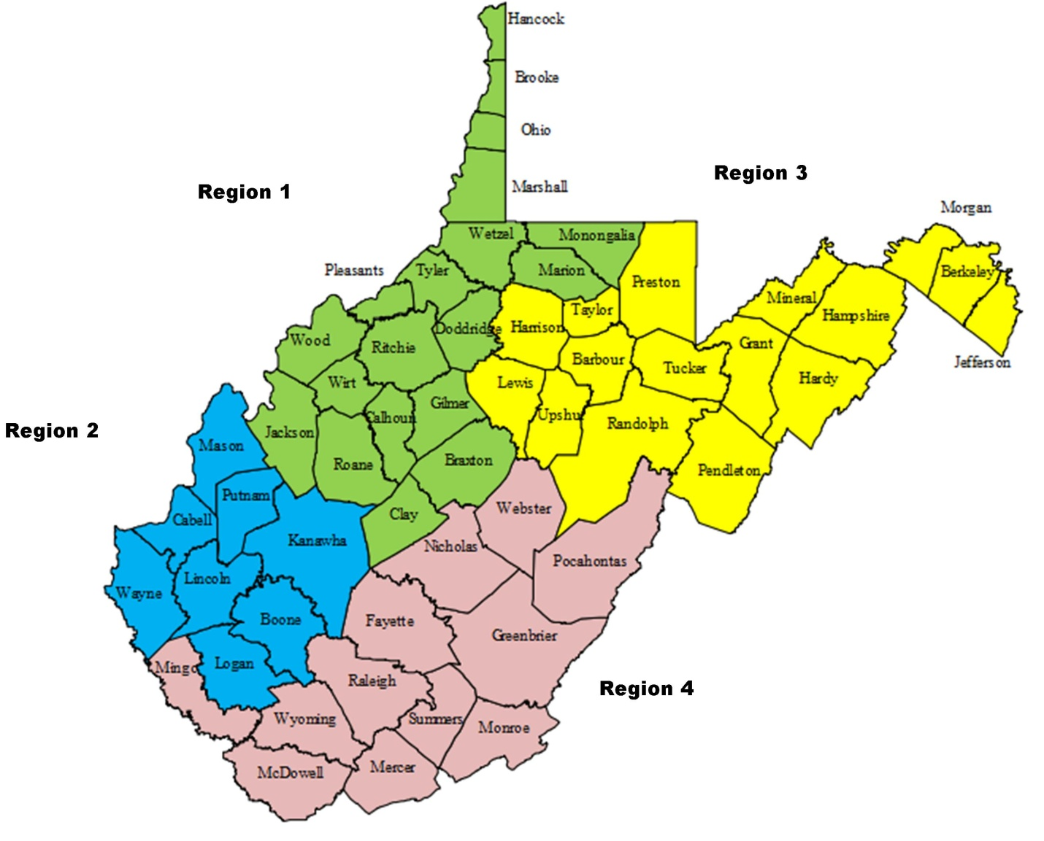

Males again outnumbered females in 2020. Overall, 62% of students were males, 38% were females. Average age at entry is 16 years old for both. Status offenders were more prevalent than juvenile delinquents across all programs.

# Permanency of Life

Positive outcome measures stipulate that 70% of all kids receiving services for 90 days or longer will be discharged to a home setting (foster home, birth family, adoptive, kinship care, lesser restrictive, or independence). Permanency is a term used in the child welfare system and it is sometimes confused with the word adoption. What permanency really means is that a person has legal membership in a safe, stable, nurturing family with relationships that are intended to last for a lifetime. Less restrictive care is often used as a step-down on the way to a permanent home. Infrequently, the youth in our care have issues that require more intensive treatment and are referred to more restrictive placement.

In 2020, Academy Programs achieved 88% success rate in achieving a positive permanency of life for the children discharging from care. 99 of the 112 children discharged went to a home setting.

# Presenting Diagnosis (Substance Abuse)

Yore Academy and YALE Academy students have co-occurring issues that are treated through cognitive-behavioral methods of behavioral change. This approach is designed to teach them coping skills which will help them remain substance free after discharge from the program. The diagnoses below were primary at intake.

# Presenting Diagnosis (Behavioral Health)

Presenting diagnoses are similar from program to program, with disruptive behavior disorder category being the most prevalent.

# Success Rate

Successful discharges are achieved through planning. Discharge planning begins at the onset of treatment. A detailed discharge plan can help with the ups and downs of life after leaving the structure of residential placement, helping to provide stability and peace of mind. All facets of the youth’s ecology are taken into consideration when planning for discharge. Optimally, the entire treatment team provides input. Sometimes children are discharged prior to a solid plan being developed. They may be released at court prior to completion of the program, exhibit increased behaviors requiring immediate removal or elope and remain at large.

Academy Programs completed 92% planned discharges in 2020, an increase from the year prior. All of the females were successfully discharged.

# Graduating Academy Programs

In our efforts to generate outcomes that are evidence based in accordance with our company values, we have developed and implemented Graduating Academy Programs (GAP) in the treatment milieu. This six phase program is designed to accurately and consistently identify the steps a child must take in order to complete the program and make the strategies of this program a consistent component of the treatment planning process. Through the application of this program, the Academy is able to offer a consistent product to our referral sources as well as an effective treatment intervention for our student population. We are able to benchmark a child’s progress through the program and identify areas that a child must address and master in order to complete the program. The focus of the GAP program is completion of treatment milestones within the milieu and is specific to each child’s individual treatment needs. It allows us to readily identify treatment objectives upon entry and provides each child a tangible list of objectives. The program allows children to gauge where they are in the treatment process and identify future challenges to complete the program. It also allows the parent(s), social worker, JPO, and judges to readily track a child’s progress through the program.

Children who need additional help navigating treatment are placed in GAP group to assist them with overcoming problem areas. This often provides the “push” they need to move onto the next challenge.

The Academy believes that a child who has successfully addressed the challenges at each bridge in the GAP Program has effectively overcome the deficits that prevented them from living successfully in their natural environment. Behavioral and substance abuse issues have been addressed through clinical intervention and successful daily living. Academic deficits have been repaired and the student has been in the care of our Transition Specialist who will follow the student back into their home school to ensure a successful transition.

Students who have graduated or have completed bridge 5 or above are considered an optimal discharge. Over 79% of those leaving Academy Programs are in this category.

# Child and Adolescent Functioning Scale (CAFAS)

The Child and Adolescent Functional Assessment Scale assesses the degree of impairment in youth with emotional, behavioral, psychiatric, or substance use problems. The CAFAS provides an objective, comprehensive assessment of a youth’s needs that is sensitive to change to over time, making it the most widely used outcome measure available. CAFAS scores at intake can predict subsequent episodes of care, care that is more restrictive, and cost of services. In addition, intake CAFAS score can be predictive of future contacts with the law and school attendance. In a study with youth in a youth & adolescent justice residential center, higher CAFAS scores at discharge predicted recidivism during the year after discharge (Quist & Matshazi, 2000).

# Self-Management and Recovery Training (SMART)

SMART Recovery is an abstinence-oriented method for individuals with addictive problems. The self-empowering, mutual support meetings focus on ideas and techniques to help change your life from one that is self-destructive and unhappy to one that is constructive and satisfying. SMART Recovery does not use labels like “addict” or “alcoholic.” We focus on present-day events and the causes of self-destructive behaviors. We concentrate on what to do about them to achieve a positive lifestyle change, especially in the areas of our lives that are related to harmful addictive behavior.

SMART Recovery’s approach to behavioral change is built around a 4-Point Program®: (1) Building and maintaining the motivation to change. (2) Coping with urges to use. (3) Managing thoughts, feelings, and behaviors in an effective way without addictive behaviors. (4) Living a balanced, positive, and healthy life.

All of the youth on campus attend SMART Recovery groups multiple times per week.

# Referrals

Academy Programs continues to receive referrals on an almost daily basis. Not all referrals for children needing treatment services can be accommodated. Some are not appropriate for our services, while others may need more immediate attention that can’t be provided at that time.

Referrals are received from all regions in West Virginia. During the global pandemic, the number of referrals across the state was diminished from the year prior.

 

# Critical Incident Review Team (CIRT)

The Critical Incident Review Team reviews all incidents and incident reports in order to investigate any incident which may have had the potential for harming a student or students emotionally or physically. Findings of the CIRT team are reported monthly to the Safety Committee. Staff are diligent in recording all manner of incidents. It is important to note that a single episode/incident report may have several types of incidents included. For instance, an occurrence of negative behavior may include physical aggression, verbal threats, and physical intervention. In 2020, there was an increase in incidents within the Youth Academy, but the safety of students and staff was maintained.

|  |  |  |  |
| --- | --- | --- | --- |
|  | **YOUTH ACADEMY** | **YORE ACADEMY** | **YALE ACADEMY** |
| **TOTAL INCIDENTS** | **1893** | **684** | **529** |
| **AVG. INCIDENTS PER DAY** | **5.2** | **1.9** | **1.4** |

# Safety Committee Report 2020

Monthly Walk Through Report:

The walk-through reports in 2020 were completed in a timely manner and addressed minor maintenance and repair issues due to damage caused by students. Cottage cleanliness was also monitored closely. No trends or patterns were noted. Most monthly reports noted messiness of different cottages, but no group was repeatedly singled out.

Fire Drill Report:

Monthly review of fire drill records indicate that fire drills occurred monthly and were completed successfully. Drills are intended to be completed at different times of the day to include all staff.

Outdoor Programming/Safety & Supervision:

Outdoor programming was implemented by individual groups instead of multiple groups working together. Construction of the Hogan was completed without any safety concerns. Pandemic preparedness was observed throughout campus. Additional cleaning and sanitation was implemented due to Covid -19.

CIRT Report:

Critical and noncritical incidents are monitored closely. Overall incidents in Youth Academy increased in 2020. These were attributed to specific students with maladaptive behaviors. De-escalation techniques were utilized to reduce physical confrontation. Physical Intervention was used to keep students safe. An increase in Away from Supervision was noted and was kid specific. All suicide threats/ideations were immediately referred to the Director of Treatment for assessment and plan of action. Substance Abuse incidents decreased, largely due to the reduction in off campus visits.

Grievances:

One grievance was received in 2020 and it was resolved quickly. Some students had complaints regarding perceived injustices or favoritism that were addressed as they occurred.

# Community Family Intensive Treatment (CFIT)

CFIT (Community Family Intensive Treatment) is designed to provide an array of services to assist at-risk families and children of all ages. The model is a combination of Social Necessity and Medical Necessity services and allows the child and/or family to receive specific attention to their needs. The primary service requested in 2020 was a Comprehensive Assessment Planning System or CAPS. It is an assessment of needs and strengths that cumulates in a plan of recommended services or actions. After February 2020, all in home services were halted due to the global pandemic.

# General Staff Patterns and Turnover

Staffing patterns in 2020 remained the same although Covid-19 contributed greatly to staff turnover rate. A total of 18 full-time, direct care staff left their positions at Academy Programs in 2020. Adjunct positions lost 23 people. The total turnover rate for direct-care positions was 53%, while the remaining staff turnover rate was 48%, an increase from past years.

As a company we still encounter the same obstacles with staffing. The Academy is not competing with like companies to retain employees, but rather with other industries that provide the same or higher salaries and do not include the level of tension and stress that is commonly associated with this industry.

# Satisfaction Surveys

Surveys were distributed to staff, families and youth in 2020 to gauge their satisfaction in multiple key areas. Gap analysis shows the difference between how important attributes/services are to survey takers and how satisfied they are with those attributes/services. By comparing importance (blue) and satisfaction (red) scores in the charts below, we used gap analysis to identify priorities for improvement.

***Staff Satisfaction***

Areas that were identified as opportunities for improvement were compensation and the work schedule for direct care staff.

***Student Satisfaction***

The Youth Academy students identified that they would like to be more involved in treatment planning.

Yore Academy identified meeting medical needs in a timely manner was an area that they felt needed improvement.

The YALE Academy students did not identify any areas that needed improvement.

***Family Satisfaction***

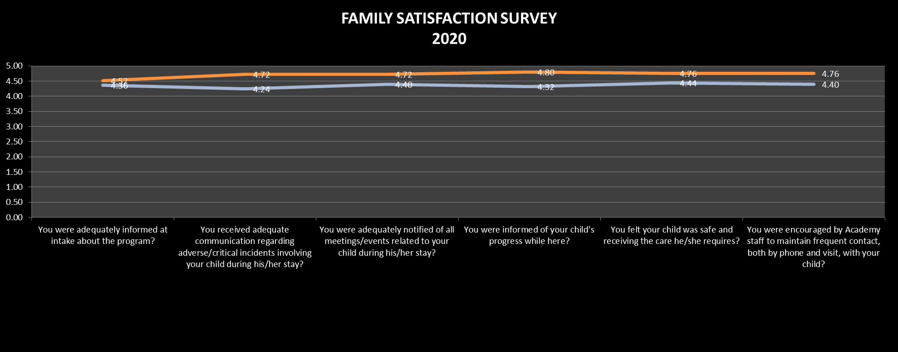

Families were pleased with all areas surveyed.

# Expenditures and Revenue

Expenditures for 2020 are divided between Administrative and Management costs and Treatment and Program services. Revenue sources are WV DHHR, WV Medicaid and payment for CFIT services.

**YOUTH ACADEMY**

**________________Sources of Revenue_______________% of Revenue____Dollar Amount_**

**WVDHHR 73.2% $1,453,014.00**

**WV Medicaid 26.7% $530,438.00**

**CFIT 0.1% $1166.00**

**Total: $1,984,618.00**

**YORE ACADEMY**

**________________Sources of Revenue_______________% of Revenue____Dollar Amount_**

**WVDHHR 77% $1,878,252.00**

**WV Medicaid 23% $567,977.00**

**Total: $2,466,229.00**

**YALE ACADEMY**

**________________Sources of Revenue_______________% of Revenue____Dollar Amount_**

**WVDHHR 77% $1,863,148.00**

**WV Medicaid 23% $567,536.00**

**Total: $2,430,684.00**