Annual Overview and Summary Academy Programs 2021
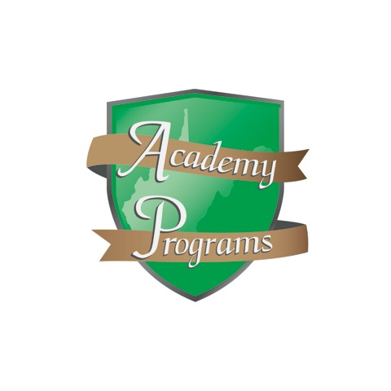
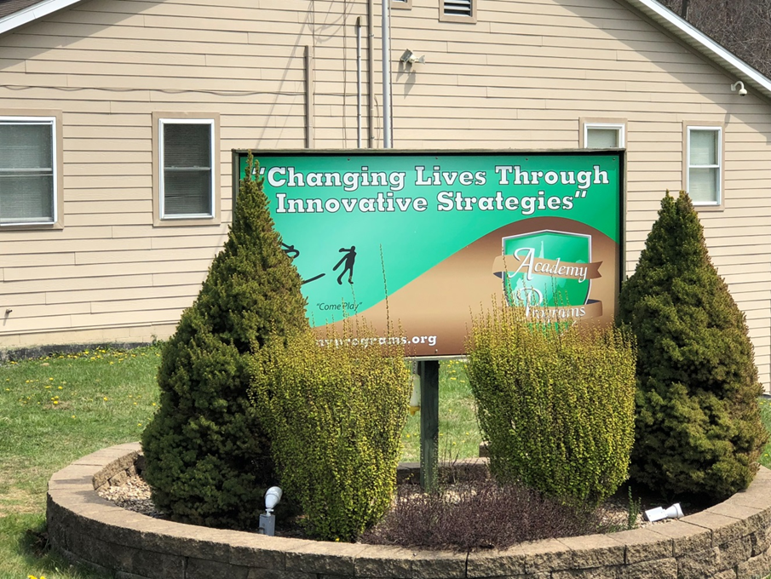

2021 has been another difficult year where program operations were unduly complicated by the fallout resulting from the presence of the COVID-19 virus and our society’s response to it. While 2020 presented the Academy with many of the same challenges, it was approached as an opportunity to overcome new challenges and practice new innovations in services, the longevity of the challenges experienced throughout this ordeal have started to take a toll on the staff at Academy Programs. It has only been through the resolute dedication and commitment of our staff that we have been able to overcome the challenges of 2021, but have been able to effectively maintain the highest possible standard of care for our students.
Nicholas Hobbs, the founder of Project Re-ED, referred to Re-ED practitioners as a “colleagueship of discovery” and stated that Re-ED “must be re-invented every day”. Surviving 2021 has required us to embrace this challenge with more commitment to this idea than ever before. Stagnation in the job market and the resulting staff shortages throughout the year required veteran staff to come together in support of one another to work longer hours and to take on additional responsibilities. Although this struggle has been taxing on our staff, we witnessed the benefit of having veteran staff working more closely with our student body. The result has been an ability to maintain the highest possible standard of care, in spite of the worst possible of circumstance. I believe Hobbs would be proud of our embrace of this ‘colleagueship’ as we have navigated the troubled waters of this world-wide pandemic.
Active engagement in learning is a critical component to Re-ED programming. In fact, one of the factors that differentiate Re-ED schools from other academic institutions is the rich level of engagement and the promise each day brings for opportunities to explore, learn, and have adventure. Our most significant easement in overcoming the challenges of 2021 has been the benefit of returning to the classroom on a fulltime basis. Students are once again seeing success in education, which results in an improvement in adjustment, with those improvements in adjustment carrying on outside of the classroom.
Nicholas Hobbs, the founder of our treatment philosophy, tells us that “perhaps the one
thing that most sharply differentiates a Re-ED school from any other residential program for children is the fullness and purposefulness of each day in the life of a child.” (Hobbs, 1982, p. 88). In applying this philosophy in our work for over a decade, we were successful in the provision of a treatment program rich in engagement and a student body vested in engaging in the treatment process. In addition to seeing a return to normalcy in our school day, our treatment programming has also enjoyed a slow return to increased levels of engagement. Our ability to slowly return to consistency in our programming has also been contributory to our success.

The 2021 Academy Programs Annual Report will go into greater detail by addressing information in the following areas:

- Academics
- Average Daily Census and Occupancy Rate
- Average Length of Stay
- Total Number of Students Served
- Referrals
- Permanency of Life Situation
- Presenting Diagnosis (Substance Use)
- Presenting Diagnosis (Behavioral Health)
- Success Rate
- Community Family Intensive Treatment (CFIT)
- Graduating Academy Programs
- Child and Adolescent Functional Assessment Scale
- Smart Recovery
- Incidents
- Safety Committee Report
- General Staffing Patterns
- Staff Retention and Turnover
- Satisfaction Surveys
- Expenditures & Revenue

Academics

This year was another one of adaptations to provide the best education while operating in a challenging environment. In order to minimize Covid-19 contamination, students remained in their dedicated classroom while the teachers travelled across campus, providing instruction in all classrooms. This method also helped to minimize distractions and reduce transition time between classes. Students and teachers remained vigilant and sanitized appropriately throughout the school day.
Throughout all of the challenges, our school continues to be the highest academic performing school among all WVDE residential on-grounds schools since we completed our first year in 2008-2009.
Again this year, over 600 credits were earned towards high school graduation. There were 25 high school graduates through Options Pathway or traditionally.
Twenty-two students earned their TASC (Test Assessing Secondary Completion) while at Academy Programs. Another 100% success rate in passing the TASC test!
Eight credits are available to be earned during the traditional school year
  - Five core subjects of PE, Math, English, Science, and Social Studies
  - Special Education and Options Pathways
  - Electives include but are not limited to Automotive Technology (Students are able to earn a National certification as a student ASE Certified Mechanics), Facilities Maintenance, Career Integrated Experiential Learning, Communications, Geography, Piano, Art, Music Appreciation, Health, Fitness, Computer Applications, Psychology, Sociology, Medical Terminology, Parenting, Child Development, Criminal Justice, Test Strategies, Journalism, Virtual School programming
A full thematic based summer school is offered in which students can earn up to two credits towards high school graduation (the majority of public schools systems do not offer summer school). Our summer curriculum is designed to be “hands on learning”.
All student grades, transcripts, etc. are kept on the statewide public school computer system “WVEIS” (West Virginia Education Information System) which makes the transfer of student data for transition back to public schools immediate and seamless.
We are a Federal “Title I” school which enables us to receive federal funding to run academic programs for at risk children. This includes tutoring (4 tutors), a full time Reading Intervention Specialist, a full time Math Intervention Specialist and a full time Transition Specialist who provides discharge transition services for up to 12 months.
Our Automotive Technology CTE program and our Facilities Maintenance CTE program enable our school to do the “Option Pathways,” which increases opportunities to earn a high school diploma through alternative methods. Our Automotive Technology program has received commendations for the effective implementation of Simulated Workplace initiatives
Auto Tech students earn national ASE Student Certification in multiple areas of auto technology. This year we had three students earn ASE certifications. This certification is recognized as the industry standard for mechanic competency in the automotive repair industry.
Additional certifications achieved include:
- 40 ServSafe Food Handlers cards
- 50 ProTrainings CPR Certifications
- 25 OSHA 10-hr Cards
Students may be enrolled in distance learning classes to supplement our direct delivery:
  - “Credit Recovery” classes for students that have previously failed a class and need to retake that class for a credit
  - “Virtual School” for students that need a particular class that our school either can’t offer or that class won’t fit in our course offering schedule
  - College classes
  - Career Technical Education coursework

Two measures of academic success, credits earned and GPA, are illustrated below:

Academy Programs wishes a very happy retirement to Matthew Kittle. In 2008, he became the first principal for the on-grounds school at Academy Programs, a position he maintained until his retirement in early 2022. Under his excellent guidance, the school helped countless students attain academic success. We appreciate all his hard work in the past and wish him well in his future retirement endeavors.

Average Daily Census and Occupancy Rate

Academy Programs served 155 at-risk children in 2021. The normal attendance for Youth Academy is 22 students and 24 students each for Yore and YALE Academy. This year the average daily census for Youth Academy was 21, while Yore was 22 and YALE Academy was 23. As we again dealt with COVID- 19, we continued to have a slightly lower than normal census. As usual, we served more males than females throughout the year. The chart below represents a comparison of occupancy rates for the past four years.

 | 2018 | 2019 | 2020 | 2021
YOUTH ACADEMY | 99.9% | 100.7% | 96.6% | 93.6%
YORE ACADEMY | 100.1% | 102.5% | 95.2% | 92.3%
YALE ACADEMY | 103.4% | 103.5% | 94.6% | 96.0%

Average Length of Stay

Academy Programs utilizes varied practices and takes into account the specific needs of the student to accommodate them within the scope of the program. Though there is no exact duration of treatment recommended for all situations, research has found that successful outcomes directly relate to participating in treatment for an adequate length of time. Every student is different and will respond to treatment differently, and in different timeframes. There is no length of time that a residential treatment program should last, but it is essential to give the student ample time in the program to allow for the best recovery outcome. It is also important to note that treatment does not subside at the completion of the treatment program. It is essential to continue practicing the lessons learned and utilize the tools that were taught during the treatment program after it is completed. Following an aftercare plan to help with maintained success will benefit the student, as it is a direct plan to help them continue to integrate healthy habits into their outside lives.
Academy Programs provides accountable and effective treatment services which are delivered in the least restrictive and most efficient manner. Our goal is to make each student’s stay in congregate care as meaningful as possible, while ensuring they do not leave without the necessary skills to be successful.
In 2021, the overall average length of stay dropped slightly from the year prior to 8.2 months. As illustrated in the chart below, the majority of the students complete the program in 7 – 9 months.

Referrals and Total Number of Students Served

According to the WV System of Care, a group residential facility is a structured 24 care setting that is less intense therapeutically and less secure than a psychiatric residential treatment facility.
Youth who are appropriate for this level of care may have the following behaviors:
- Problems following directions
- Arguments with parents, siblings, teachers, etc.
- Mild self-injurious behaviors, risk taking, promiscuity, impulsive behaviors, etc.
- Possible suicidal thoughts but no intent
- Fights at home, school or community
- Verbally aggressive outburst
- Property damage
- Low-Moderate risk for sexually victimizing others
- Possible involvement in the legal system
- Not always able to function at school-truancy, suspensions, expulsions
- Not always able to function in the community
- May need constant supervision even at night.
- May need further support while transitioning to a home setting
- Has not been successful in multiple placements including foster care, group residential and psychiatric residential treatment

The severity of the behaviors above and the clinical needs of the child are taken into consideration when referrals are made to individual agencies.
Referrals are received from all regions in West Virginia. Those regions are illustrated below.

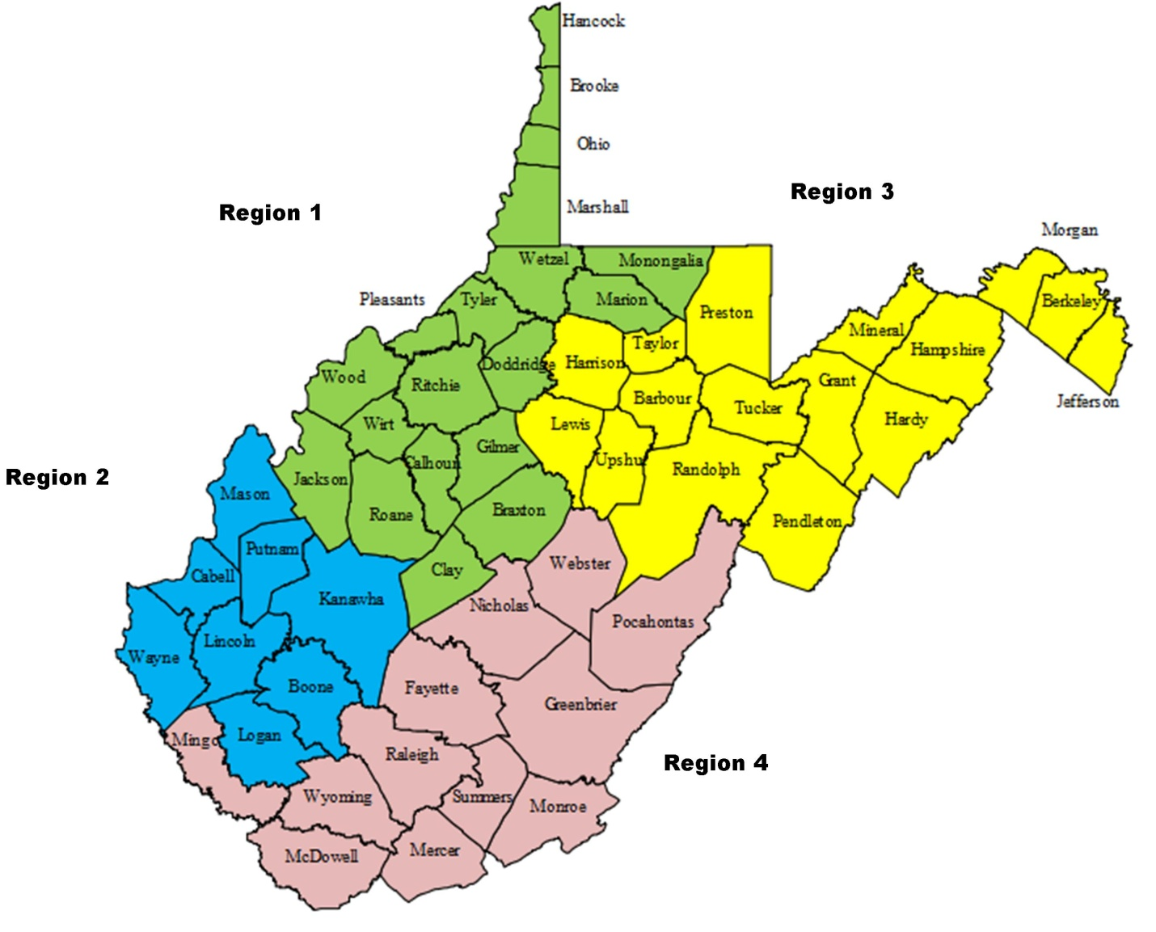

Academy Programs received referrals of students from 34 counties who were in need of services in 2021.

Unfortunately, not all referrals can be served. A total of 899 students were referred for treatment in 2021 and Academy Programs was only able to serve 17%. As illustrated in the chart below, not all of them were appropriate for our programs.

Permanency of Life

Permanency often means family. It means having positive, healthy, nurturing relationships with adults who provide emotional, financial, moral, educational, and other kinds of support as youth mature into adults. Positive outcome measures stipulate that 70% of all kids receiving services for 90 days or longer will be discharged to a home setting (foster home, birth family, adoptive, kinship care, lesser restrictive, or independence). Less restrictive care is often used as a step-down on the way to a permanent home. Infrequently, the youth in our care have issues that require more intensive treatment and are referred to more restrictive placement.
In 2021, Academy Programs achieved 88% success rate in achieving a positive permanency of life for the children discharging from care. 78 of the 88 children discharged went to a home setting.

Presenting Diagnosis (Substance Abuse)

Yore Academy and YALE Academy students have co-occurring issues that are treated through cognitive-behavioral methods of behavioral change. This approach is designed to teach them coping skills which will help them remain substance free after discharge from the program. The diagnoses below were primary at intake.

Some Youth Academy students have substance abuse diagnoses upon admission although it is not the norm. Only 17% of students had a substance abuse diagnosis at entry.

Presenting Diagnosis (Behavioral Health)

ADHD, anxiety problems, behavior problems, and depression are the most commonly diagnosed mental disorders in children and adolescents. As shown in the charts below, ADHD and behavioral problems are the prevalent diagnoses upon admission.

Success Rate

A measure of success achieved can be viewed through discharge planning. Discharge planning begins at the onset of treatment with the student’s entire treatment team and family. Every area of the youth’s ecology is addressed when planning for discharge. At times, a discharge is planned prior to program completion because the student has some clinically significant issues that are best addressed in a more intensive setting. Academy Programs will assist in the transition to a different setting through discharge planning, whether it be to another placement or the student’s home.
Academy Programs completed 97% planned discharges in 2021, an increase from the year prior. The only unplanned discharges occurred in Yore Academy due to unforeseen circumstances (elopement from home visit and court ordered transfer).

Community Family Intensive Treatment (CFIT)

CFIT (Community Family Intensive Treatment) is designed to provide an array of services to assist at-risk families and children of all ages. After February 2020, all in home services were halted due to the global pandemic. CFIT did not provide any services during 2021.

Graduating Academy Programs

The GAP program is grounded in an ecological, holistic approach with the philosophy of Project Re-ED. It is easily molded into Academy Program’s implementation of Re-ED principle and practice creating continuity in all treatment interventions, idiom and maintenance of the daily treatment milieu. It incorporates objectives for daily conduct within the program and measures that conduct in a way that tracks improvement in performance throughout the course of treatment. It addresses progress on clinical treatment goals and objectives and allows for assessment over the course of the treatment process to determine if the goals and objectives are appropriate for the student in question. The system includes family involvement in the treatment process and tracks and addresses that involvement and functioning in accordance with where the child rests in the course of treatment.
The Gap program incorporates a zero-tolerance approach for the most dangerous and concerning behaviors including substance abuse, being absent without permission (running away), and possessing contraband and paraphernalia while on Academy Programs’ property, It uses a graduated scale for performance in all aspects of treatment to allow for consistent student improvement throughout the course of the treatment process.
The focus of the GAP program is completion of treatment milestones within the milieu. The program allows students to gauge where they are in the treatment process and identify future challenges to complete the program. It also allows the parent(s), social worker, JPO and judges to readily track a student’s progress through the program and allows us to objectively identify obstacles a child must overcome to successfully complete the program.

The disturbed child finds himself immediately committed to a new way of living at once more satisfying to himself and more satisfactory to the people in his life. Indeed, when a day’s program is well planned and executed, when things are going well with the group, it is exceedingly difficult for a disturbed child to behave in a manner that earlier caused him to be so described. Such a day is by no means easy to make happen. It takes good people, extensive resources, and careful planning. (Hobbs, 1982, pg. 89)

The Academy believes that a child who has successfully addressed the challenges at each bridge in the GAP Program has effectively overcome the deficits that prevented them from living successfully in their natural environment. Behavioral and substance abuse issues have been addressed through clinical intervention and successful daily living. Academic deficits have been repaired and the student has been in the care of our Transition Specialist who will follow the student back into their home school to ensure a successful transition.
Once a student has completed all six bridges of the GAP program, they are ready for graduation. Students who have graduated or have completed bridge 5 or above are considered an optimal discharge. On average, over 88% of those leaving Academy Programs are in this category.

Child and Adolescent Functioning Scale (CAFAS)

The Child and Adolescent Functional Assessment Scale (CAFAS: Hodges, 2000a; 2000b), assesses the degree of impairment in youth with emotional, behavioral, psychiatric, or substance use problems. The CAFAS is designed to determine the youth's ability to function in daily life, inform treatment plans, and measure functional change over time. At intake, the score is often elevated, reflecting a need for intensive services. As the student progresses through treatment and develops the skills they need to stay safe in their home, school and communities, the score decreases. The decrease in score reflects improvement in daily functioning.

Self-Management and Recovery Training (SMART)

SMART Recovery finds its roots in a scientific approach to recovery. The program works under the theory that addiction can be cured through evidence-based therapies like Cognitive Behavioral Therapy and Dialectical Behavioral Therapy. The program also uses the principles of motivational interviewing and uses therapeutic options to teach addiction sufferers how to recognize the causes of their addiction and how to change their behaviors through coping mechanisms. SMART Recovery is an abstinence-oriented method for individuals with addictive problems.
SMART Recovery’s approach to behavioral change is built around a 4-Point Program®: (1) Building and maintaining the motivation to change. (2) Coping with urges to use. (3) Managing thoughts, feelings, and behaviors in an effective way without addictive behaviors. (4) Living a balanced, positive, and healthy life.
All of the youth on campus attend SMART Recovery groups multiple times per week.

Incidents

Every incident within Academy Programs is documented and tracked so that trends and patterns can be identified and comparisons made over time. The Safety Committee reviews incidents at each meeting to determine if a particular category of incidents is elevated or if further action is necessary. The bulk number of incidents within the programs over a year can seem sizeable, but divided into daily occurrences; they are quite small and manageable, at a little over one per day. There has been a reduction in incidents over the past year across all programs. The Youth Academy dramatically decreased incidents by over 70% through successful application of de-escalation techniques and other strategies developed to address different categories.

Safety Committee Report 2021

Monthly Walk Through Report:
No trends or patterns were noted. Most monthly reports noted messiness of different cottages and minor damages in need of repair.
Fire Drill Report:
Each fire drill was completed monthly and rotated through shifts as prescribed. No issues.
Pending Safety Issues:
Sanitizing was addressed at each meeting. Weather/seasonal issues discussed as appropriate (bug spray, sunblock, and ice removal).
Incident Report:
Multiple sports-related injuries occurring in 2021. Staff instructed to have students stretch out prior to activities and to ensure that all shoe laces were tied. Monitor all games to reduce likelihood of injury. De-escalation techniques need to be better utilized when addressing aggressive behaviors. A reduction in physical interventions is noted after implementation of de-escalation. Negative Social Behaviors is a very diverse category and all manner of inappropriate behaviors are being documented there.
Grievances:
No grievances.

General Staff Patterns and Turnover

Staffing experience remains the most essential element in program success. As a company, the Academy must overcome the obstacles with staffing being experienced in all industries due to the impact of the Covid epidemic on the available workforce. While Academy Programs is not only competing with like companies to retain employees, we must also compete with other industries that provide the same or higher salaries and do not include the level of tension and stress that is commonly associated with this industry.

Our staffing challenges over the past year have not been solely the recruiting, training and retention of quality staff who work directly with children, but the absence of an available work force. In spite of our efforts to market open positions throughout the year, the number of resumes, applications, and interest enquiries has proven to be markedly lower than it has been in any year since the Academy opened in 2002. As a result, recruiting new employees to fill vacant positions has become a more complicated struggle than retaining experienced employees across campus.

Of the 116 total staff employed by the company, the Academy has operated 30-35 staff short throughout the course of 2021. In the residential direct-care ranks the company should have 54 employees at capacity, however, the Academy maintained operations with only a 52 percent staffing pattern operating with 23-28 vacant positions consistently throughout the course of 2021, while successfully maintaining the highest possible standard of care for the students in our charge. This was accomplished due to our commitment to Re-ED Philosophy that informs us that “most if not all of the full-time professional workers in a Re-ED school are teacher-counselors”. While our staff may individually perform special functions, they are all teacher-counselors by profession. In combating our staffing shortages complicated by Covid, all staff pulled together to volunteer for additional duties and to band together to ensure both the maintenance of supervision ratios, and the continuity of care for our students. This created frequent opportunities for administrative and adjunct staff to work more closely with the student body and utilize their years of experience and skill to not only maintain, but in many instances bolster, the quality of service the Academy provides.

The Academy hired 45 new employees in all positions in 2021. A total of 19 full-time, direct care staff left their positions at Academy Programs throughout the course of the year. Total length of service of those 19 employees varied from one to 22 months. While the Academy experienced minimal turnover in Administrative and Adjunct staffing positions, the total turnover rate for direct-care positions in 2021 was 35 percent, down significantly from 53 percent in 2020. As stated previously, the challenges to maintaining a full staffing pattern have not been due to our ability to retain veteran staff, rather a difficulty in recruiting new staff to fill long-standing vacancies.

In an effort to remain competitive in this industry, the Academy has taken the following steps to address the difficulty with recruiting and retaining staff in 2022:

- Increased entry level salaries for multiple positions
- Continued commitment to recruiting and signing bonuses
- Continued to offer “Hero Bonuses” for professional staff who volunteer to help fill the workload of vacant positions

As a result of this feedback from our staff, 2022 Program Improvement goals have been developed to target the following specific following areas:

- Provide additional training to direct-care staff in Life Space Intervention and Therapeutic Alliance to help build better therapeutic relationships with the kids in our care
- Involve direct-care staff in program planning for 2023
- Create better training and development opportunities for direct-care staff to create “depth on the bench”

Satisfaction Surveys

Surveys were distributed to staff and youth in 2021 to gauge their satisfaction in multiple key areas. Gap analysis shows the difference between how important attributes/services are to survey takers and how satisfied they are with those attributes/services. By comparing importance (blue) and satisfaction (red) scores in the charts below, we used gap analysis to identify priorities for improvement. Any area that has a gap of 1.0 or more is considered an opportunity for improvement.

Staff Satisfaction

No areas had a notable gap. After review of the surveys, three items were chosen to address: schedule, recruitment and job attendance. The Director of Operations conducted meetings with all staff to seek feedback and share changes in program scheduling and recruitment.

Student Satisfaction

An opportunity for improvement was noted by all programs in the taste/quantity of food, especially among males. In response, increased meal portions and snacks were supplied.
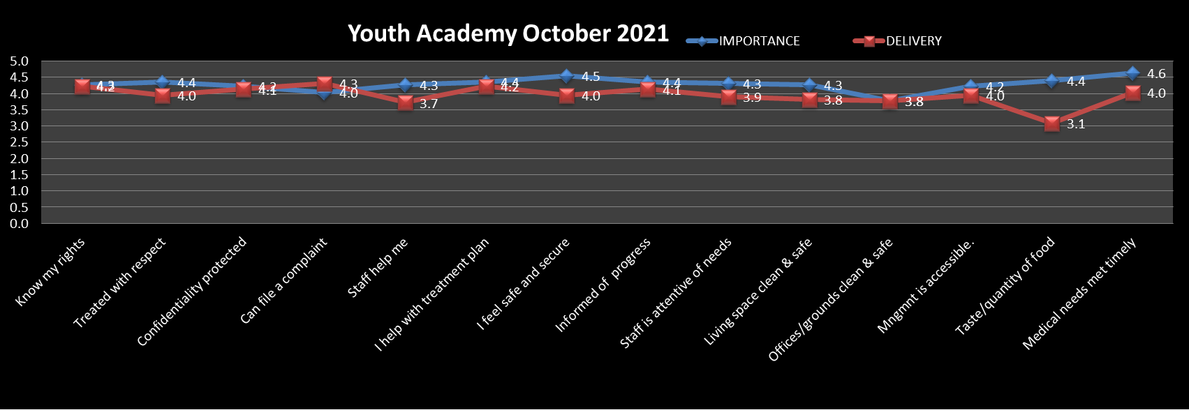
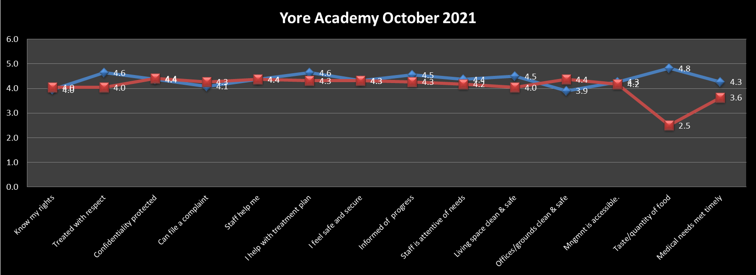
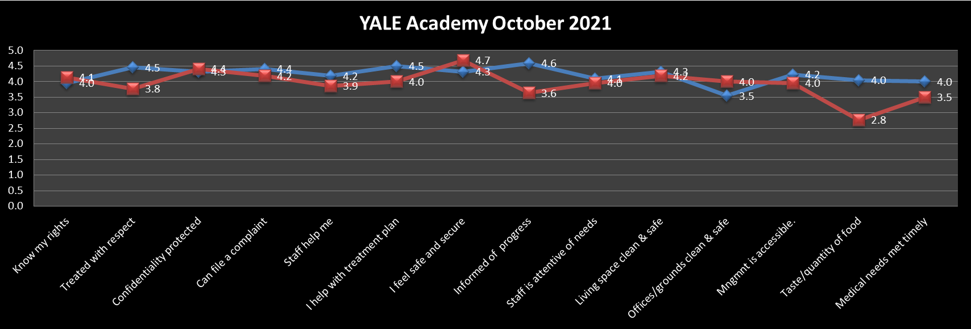

Expenditures and Revenue

Expenditures for 2021 are again divided between Administrative and Management costs and Treatment and Program services. Revenue sources are WV DHHR and WV Medicaid.

YOUTH ACADEMY
________________Sources of Revenue_______________% of Revenue____Dollar Amount_
WVDHHR 77% $1,670,000.00
WV Medicaid 23% $486,765.00
CFIT 0% $0.00
Total: $2,156,765.00
YORE ACADEMY
________________Sources of Revenue_______________% of Revenue____Dollar Amount_
WVDHHR 80% $2,133,255.00
WV Medicaid 20% $520,450.00
Total: $2,653,705.00
YALE ACADEMY
________________Sources of Revenue_______________% of Revenue____Dollar Amount_
WVDHHR 81% $2,206,605.00
WV Medicaid 19% $512,735.00
Total: $2,719,340.00

